**Azure App registration**

A scenario comes when we want to leverage the use of Graph API connector in our logic apps. For the graph API to work certain parameters needed to be passed in the Graph API connector such as Tenant ID, Client Secret, App Id etc.

These parameters are only available when an App is registered in Azure Portal.

For a single tenant a single app is only needed to be registered. We can then reuse this app for new graph API requests by adding the required permissions needed for the API.

1.Login to <https://portal.azure.com/> with admin credentials or user credentials

2.Navigate to App registrations

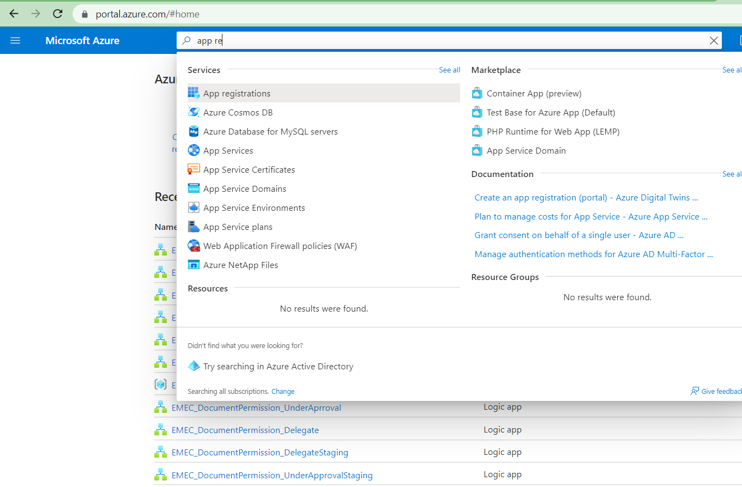

3.Click on New Registration and Register a New App

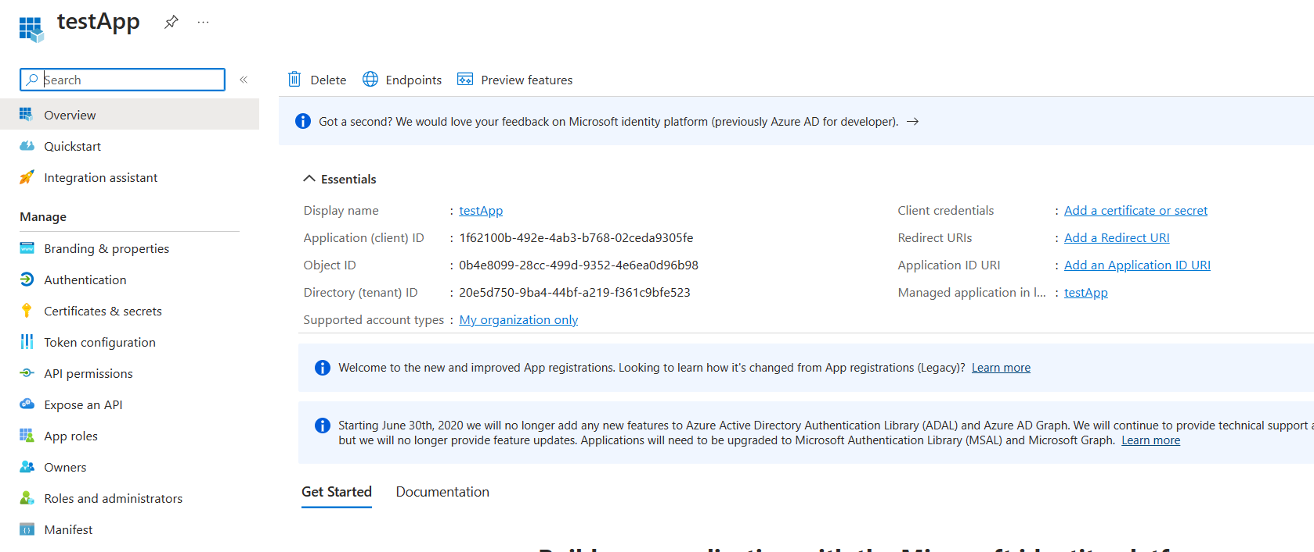

* After Registering the App a client secret needs to be generated. This will be generated only one time, so it is required to save the secret at the time of generation.

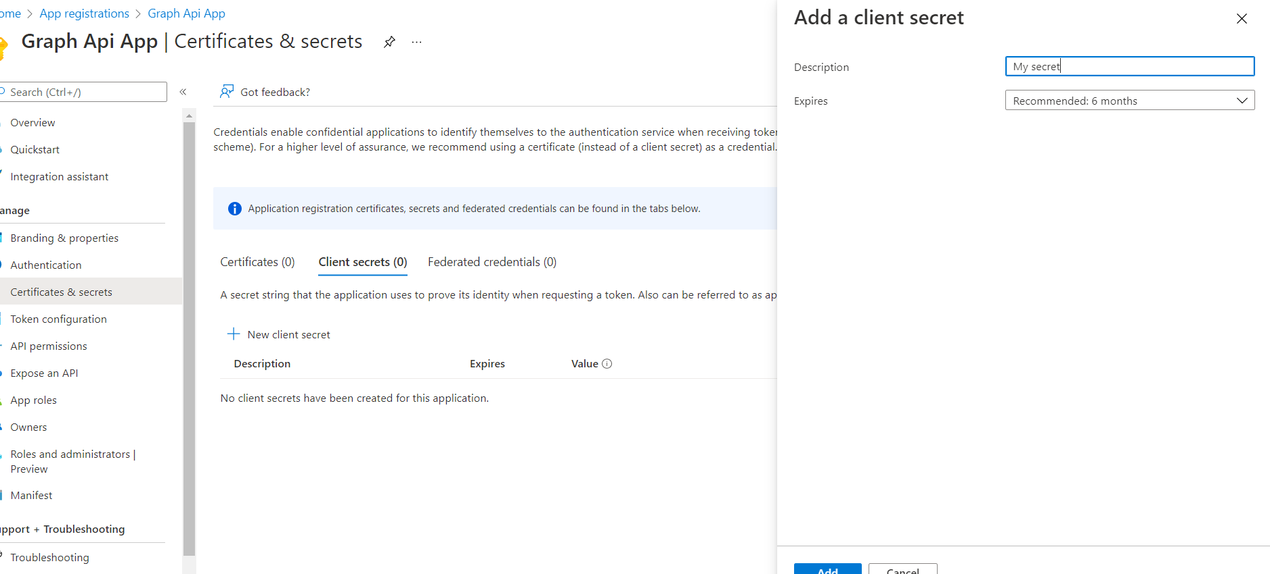

Copy the secret value and save it

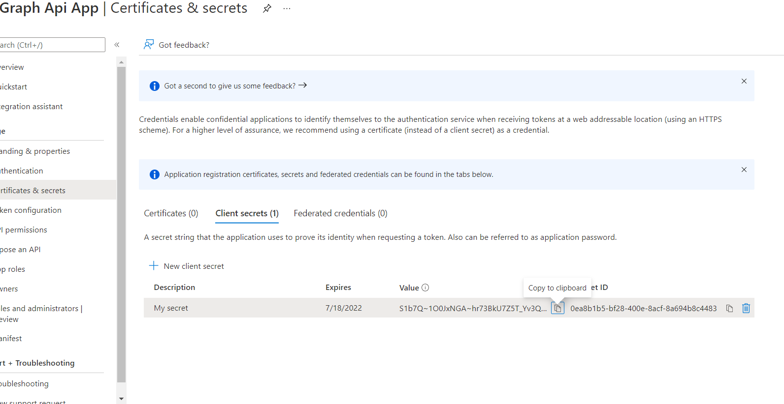

5.After creating the secret navigate to API permissions. The API permissions is

given according to the use case. To know what are the permissions needed for API navigate to Graph explorer [https://developer.microsoft.com/en-us/graph/graph-explorer](https://developer.microsoft.com/en-us/graph/graph-explorer%20and%20test%20the%20API.%20%20The) and test the API The permissions needed for API will be listed based on API request.

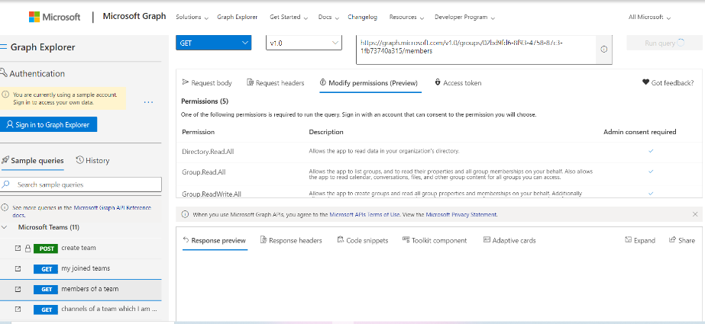

Navigate to Add a permission

Select Microsoft Graph

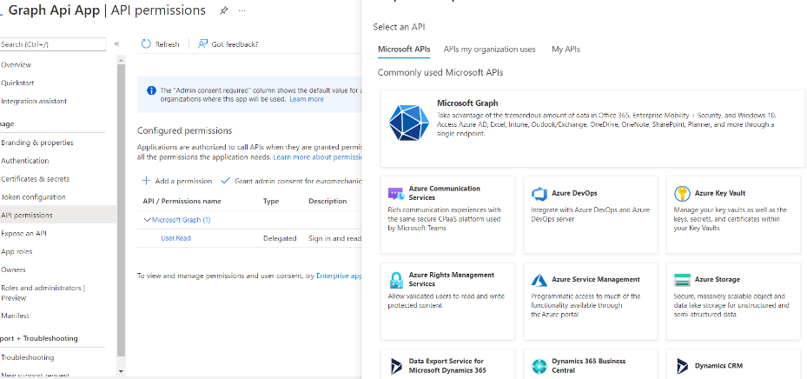

Add the required permissions for the app

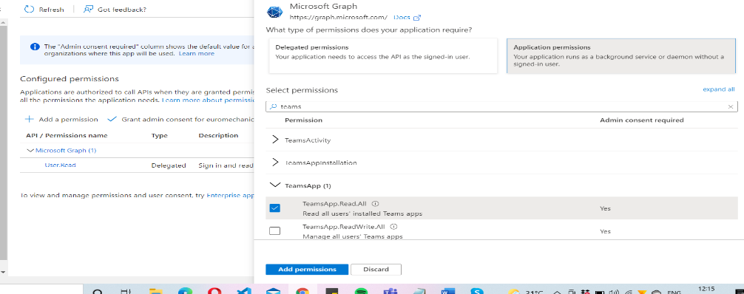

6.After Adding the permissions for the App Admin consent needed to be granted for the graph API to work

